SALES REPRESENTATIVES BUDGETS MAINTENANCE

To enter a salesman representative sales budget, first click the Budgets folder and then the ADD button. As you can add one month for one product category, then press the SAVE button and this will update the browser showing the total annual budget for the year. In this example, I have added $10,000 for period 1 with 1,250 MSF and .5 Tons for this same month.

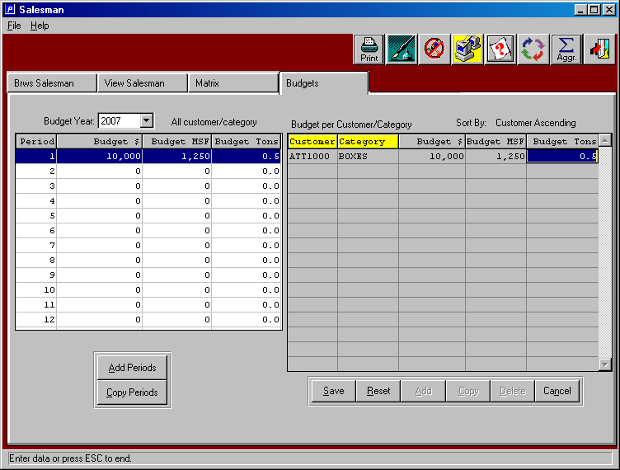

SALES REPRESENTATIVES BUDGETS MAINTENANCE

Next, I press the COPY button to copy this budget to another product category.
In this example, I will copy boxes to Press sales.
Note that Period 1 for 2007 now shows the total annual budget for this sales person.

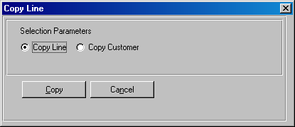

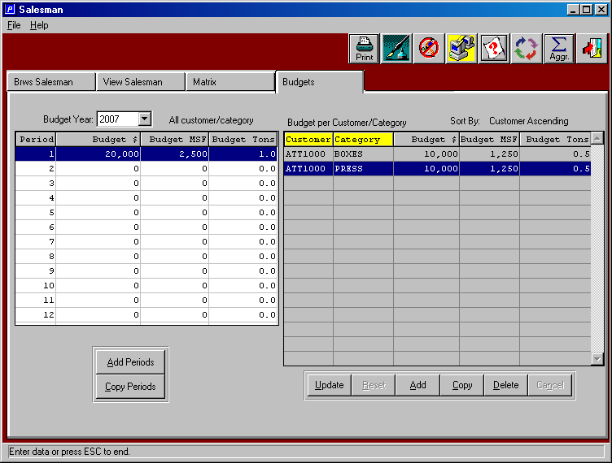

SALES REPRESENTATIVES BUDGETS MAINTENANCE

Next, I press the COPY button to copy this budget to another product category.
In this example, I will copy Press sales to Glue Only Sales.
Note that Period 1 for 2007 now shows the total annual budget for this sales person.

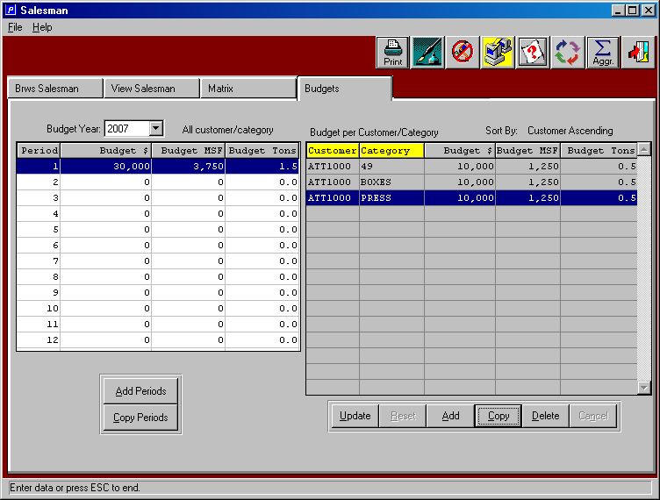

SALES REPRESENTATIVES BUDGETS MAINTENANCE

Next, I will copy the entire customer’s budgets to another customer.
Note that period 1 for 2007 is not doubled. Of course, I can make changes to any customer and any product category.

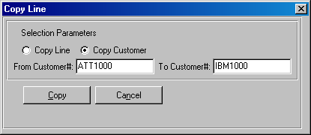

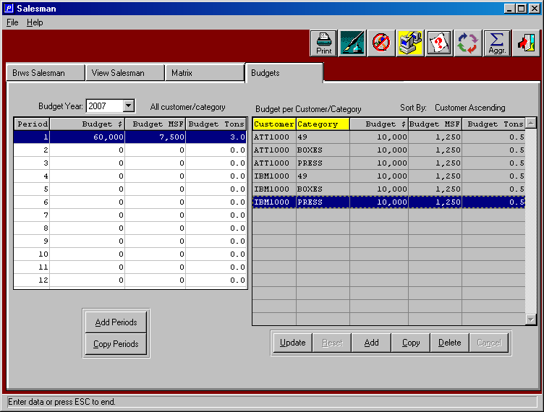

SALES REPRESENTATIVES BUDGETS MAINTENANCE

Next, I will assume that these are the only two customers for this salesperson.
Next, I will press the COPY PERIODS button and I can copy period 1 to all 12 periods.
As you can see, the entire year is not populated.

